2025 ELECTRONIC LUNCH N LEARN SERIES  
PROPELLER CLOCK

Course Title: AVAST ELECTRONICS PROPELLER CLOCK LUNCH & LEARN SERIES

Instructor and email: Brian Kelly - avast-tech@whoi.edu

Office: AVAST 108 - 508-289-3921

Office Hours: 9 to 5, Monday through Friday

Meeting Day and Time: Wednesdays from 11 to 1

Location: David Center Social hub

Course Description:

Throughout this series of Lunch & Learn events, we will learn electronic assembly and soldering skills while building an actual product from idea to finished assembly.

Learning Objectives:

* Familiarity with electronic schematic software
* Schematic design

* Circuit board design

* Build circuit board fabrication files and a bill of materials

* Part Sourcing
* Surface mount component assembly and soldering

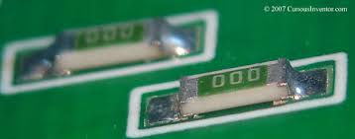

* Through-hole component assembly and soldering

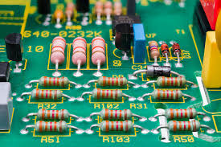

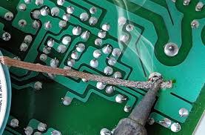 

* Methods of board cleaning and inspection



* Wire handling, stripping, crimping and tinning

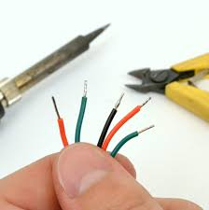

* Familiarity with Arduino programming software

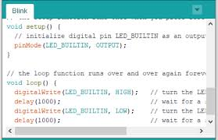

* Circuit board test and verification utilizing an oscilloscope and multimeter



* Familiarity with essential mechanical drafting software

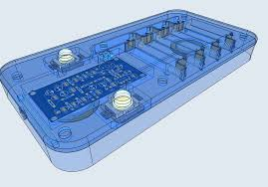

* Packaging design
* Final product assembly

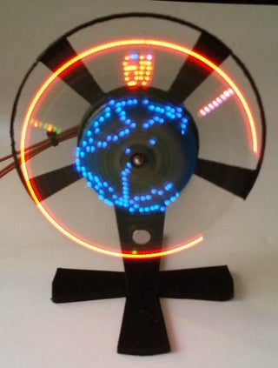

* + Software:
    - KiCAD
    - Shapr3D
    - Arduino Integrated Design Environment (IDE)
  + Component libraries:
    - <https://github.com/digikey/digikey-kicad-library/archive/master.zip>
    - [https://www.digikey.com/en/resources/design-tools/snapeda?_gl=1*13zb9pj*_up*MQ..*_gs*MQ..&gclid=EAIaIQobChMIi8yeg4iIiwMVUjcIBR39vwPoEAAYASAAEgJX-_D_BwE&gclsrc=aw.ds](https://www.digikey.com/en/resources/design-tools/snapeda?_gl=1*13zb9pj*_up*MQ..*_gs*MQ..&gclid=EAIaIQobChMIi8yeg4iIiwMVUjcIBR39vwPoEAAYASAAEgJX-_D_BwE&gclsrc=aw.ds)
    - https://www.digikey.com/en/product-highlight/a/accelerated-designs/ultra-librarian?_gl=1*13zb9pj*_up*MQ..*_gs*MQ..&gclid=EAIaIQobChMIi8yeg4iIiwMVUjcIBR39vwPoEAAYASAAEgJX-_D_BwE&gclsrc=aw.ds
* Preparing software and preparing for schematic design
  + Tutorials:
    - KiCAD

[https://www.digikey.com/en/resources/design-tools/kicad?_gl=1*t170s2*_up*MQ..*_gs*MQ..&gclid=EAIaIQobChMIi8yeg4iIiwMVUjcIBR39vwPoEAAYASAAEgJX-_D_BwE&gclsrc=aw.ds](https://www.digikey.com/en/resources/design-tools/kicad?_gl=1*t170s2*_up*MQ..*_gs*MQ..&gclid=EAIaIQobChMIi8yeg4iIiwMVUjcIBR39vwPoEAAYASAAEgJX-_D_BwE&gclsrc=aw.ds)

* + - Shapr3D

<https://www.google.com/url?sa=t&source=web&rct=j&opi=89978449&url=https://support.shapr3d.com/hc/en-us/articles/12208897524380-Video-tutorials&ved=2ahUKEwiCmpPtiYiLAxXShYkEHctlDrAQFnoECAwQAQ&usg=AOvVaw3Ih5JC9I_fXEh_bHfS65jN>

* + - Arduino IDE

<https://docs.arduino.cc/tutorials/>